As a further proposed approach, we test an alternative disease similarity measure based on shared genetic information. The motivation behind this expansion is to investigate whether gene-based disease similarity improves the drug reuse framework. By comparing this approach with the basic similarity method, the model's performance is evaluated to determine whether gene-based similarity leads to improved prediction accuracy, more reliable outcomes, or higher evaluation scores. This comparative analysis aims to assess the practical value of genetic similarity in improving drug- disease association predictions.

Our contribution is to construct an additional biologically meaningful similarity. To evaluate how similar diseases are, it is important to understand the role of genes in disease mechanisms and the biological basis of drugs. Genes are the basic units that control biological processes and contribute to the development of diseases and the body’s response to treatments. Therefore, analyzing disease similarity should consider the involvement of relevant genes. This approach is based on the idea that diseases sharing certain genes may also be similar in symptoms or drug response. Based on this, we use genes as a basis to measure similarity between diseases , allowing a more accurate representation of biological connections and helping to identify potential relationships between diseases .

Instead of treating all disease-associated genes equally, we suggest a weighted gene-based disease similarity that reflects the relative importance of shared genes, resulting in a more biologically meaningful similarity measure.

As a first step, we compute gene weights based on their disease specificity. Since genes do not contribute equally to disease similarity, we assign a Disease Specificity Index (DSI) to each gene according to the number of diseases it is associated with within the dataset. This weighting scheme allows disease-specific genes to have a stronger influence on downstream similarity calculations, while genes associated with many diseases contribute less.

The calculation of DSI is performed only within the diseases included in the dataset. Since disease similarity is analyzed among a specific set of diseases, gene specificity should be measured relative to the same set, rather than using all diseases available in large external databases. This ensures consistency between gene weighting and disease similarity analysis.

Gene–disease associations are first collected from public databases such as DisGeNET, while retaining only the associations related to the diseases included in the dataset. For each gene gi, the number of associated diseases within the dataset is then counted and denoted as Nd, while NT represents the total number of diseases considered in the study. These values reflect how broadly each gene is involved across the analyzed diseases. Based on this information, the Disease Specificity Index (DSI) is calculated for each gene using the formula:

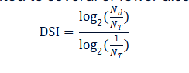

This formulation assigns higher DSI values to genes associated with fewer diseases, indicating higher disease specificity, and lower values to genes linked to many diseases. The resulting DSI values are normalized between 0 and 1 and are subsequently used as gene weights in disease–disease similarity calculations.

To compute disease similarity based on genetic information, each disease is represented as a gene-based vector. First, a global gene set G is defined, which includes all genes associated with any disease in the dataset. For each disease di, a vector Vdi is constructed, where each element corresponds to one gene from the global gene set. If a gene is associated with the disease, the corresponding vector element takes a non-zero value representing the importance of that gene; otherwise, its value is set to zero. Because each disease is associated with only a limited number of genes, its gene-based representation contains many zero values, which makes the comparison between diseases more efficient and accurate when dealing with high-dimensional genetic data.
Formally, the disease vector is represented as:

Vdi = [wi,g1, wi,g2, …, wi,gn],

where wi,g denotes the weight assigned to gene g for disease di as determined by the Disease Specificity Index (DSI).

When calculating similarity between two diseases di and dj, only genes shared between both diseases are considered in order to avoid artificially reducing the similarity score due to unrelated genes. Let Gdi and Gdj represent the gene sets associated with diseases di and dj, respectively. The shared gene set Gij is defined as the intersection of these two sets. Restricting the analysis to shared genes ensures that the similarity reflects meaningful biological overlap rather than differences caused by disease-specific genes.
The weighted cosine similarity is defined as follows:
Sim(di, dj) = (Σ_{g∈Gij} w_{i,g} · w_{j,g}) / (√(Σ_{g∈Gij} w_{i,g}²) · √(Σ_{g∈Gij} w_{j,g}²))

wi,g and wj,g are the gene weights of gene g in each disease, and Gij is the set of common genes between the two diseases.
The resulting similarity score ranges from 0 to 1. Higher values indicate stronger genetic and biological relatedness, while lower values suggest limited shared genetic mechanisms. By incorporating gene specificity as a gene weight, this improves the resulting similarity values ​​so that they are not limited to the idea of ​​diseases sharing these genes, but assign different weights to genes that reflect their importance and give a more accurate meaning to similarity.

Finally, weighted cosine similarity is computed for all possible disease pairs in the dataset. The resulting values are organized into a disease–disease similarity matrix S, where This matrix serves as the foundation for downstream analyses such as disease clustering, network construction, and drug repurposing applications.

As an extension of this proposal, we are testing the integration of an additional metric with DSI.

Within this expanded framework, we recalculate disease similarity, considering not only shared genes and their specificity but also the strength and reliability of gene-disease associations. This is known as the gene-disease association score (GDA). The GDA represents the degree of confidence in the scientific evidence linking a gene to a specific disease. This step is crucial for understanding the significance of each gene within the context of different diseases and supports subsequent biological analyses.

First, a list of diseases in the dataset under study is defined to ensure that only relevant diseases are identified. We then utilize the DisGeNET database, a comprehensive gene-disease association platform.

The GDA table contains the following main columns: gene code or gene identifier, disease identifier or disease name, and the GDA score, which represents the level of confidence in the gene-disease association. After downloading the table, the data is filtered to retain only disease-associated genes in the dataset, ensuring that each gene-disease pair has a readily usable GDA score.

This score represents the amount of scientific evidence supporting the relationship between a specific gene and a specific disease. This is crucial for classifying genes based on the reliability of their associations with diseases and for supporting further analysis.

The DisGeNET database aggregates GDA data from multiple sources, including expert-curated (Curated) databases, data derived from animal models (Predicted), and data automatically extracted from scientific texts (Litration) using text extraction algorithms. These sources vary in reliability; manually reviewed expert sources carry more weight than automatically extracted text data.

The GDA score for each gene-disease association is calculated by summing the partial weights representing the contribution of each type of supporting source. This calculation can be simplified using the following equation:
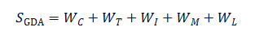

After obtaining the GDA score for each gene-disease pair, it can be combined with the gene's DSI index to obtain a final score that reflects both the gene's specificity and the reliability of its association with the disease. This can be represented by the following equation:

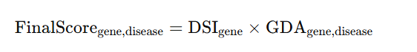

This final score assigns each gene-disease pair a weight that reflects its significance in the context of the disease. The most specific genes, those with stronger scientific evidence, have a greater impact when analyzing disease similarity or constructing biological networks. This gene weight is used to recalculate disease similarities and to utilize these similarities in graph construction, model training, and results evaluation.

The comparative evaluation provides insights into the contribution of biological knowledge at different levels.If integrating GDA improves performance, it supports the hypothesis that a richer biological context enhances drug repurposing predictions.Otherwise, it highlights the sufficiency of simpler similarity measures and avoids unnecessary model complexity.

In the context of drug similarity analysis, we can follow the same approach we used for disease similarity analysis, based on textual descriptions, to leverage the available drug descriptions in our dataset.

The concept and implementation are similar to what we did for diseases , cleaning the text, dividing it into tokens, and converting it into numerical representations(vector) using models like BERT. Each drug then has a digital vector reflecting its characteristics, which is used to calculate drug similarities. Mathematical methods, such as the cosine similarity , are used to create a comprehensive similarity table reflecting potential drug relationships. This expands the scope of the project and can be used to predict relationships with diseases.

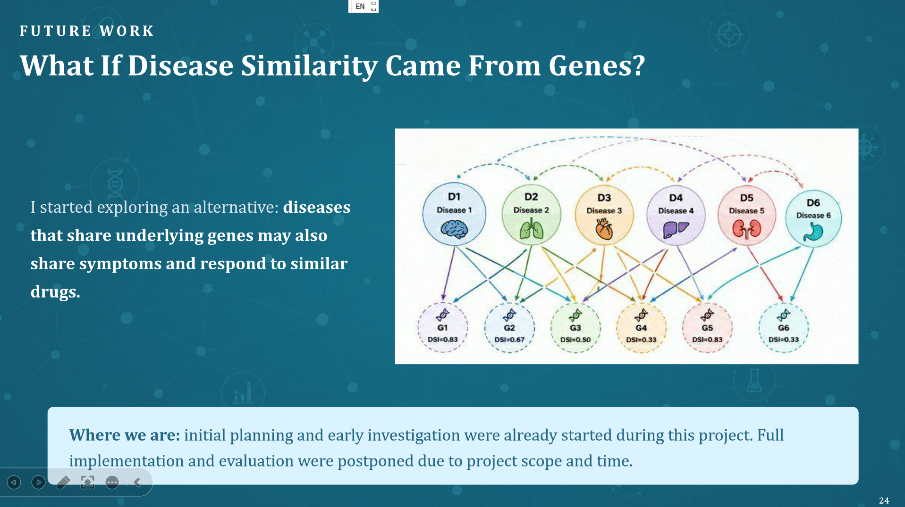
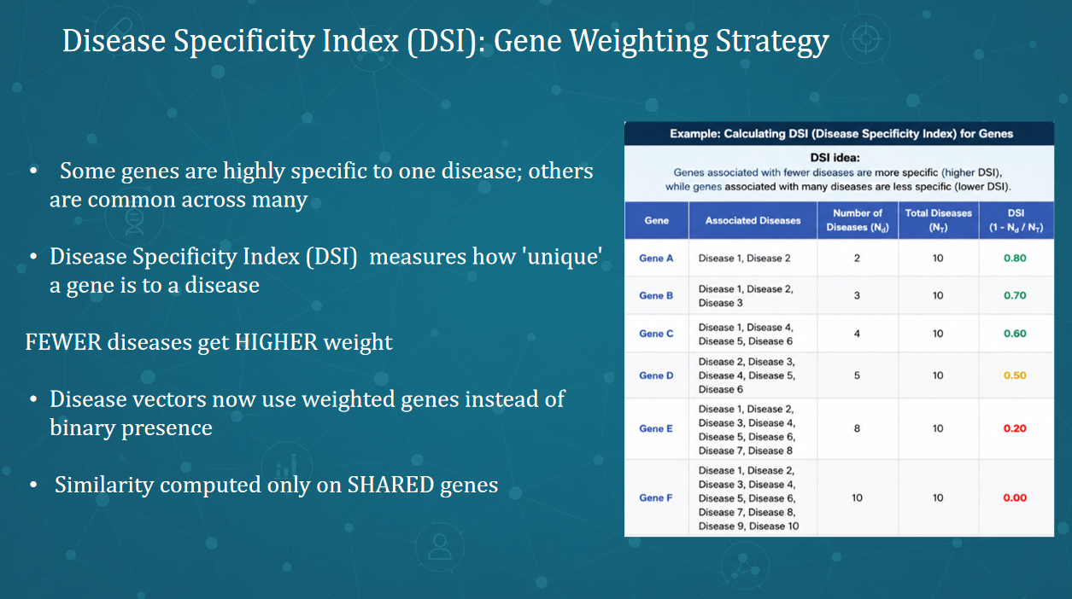
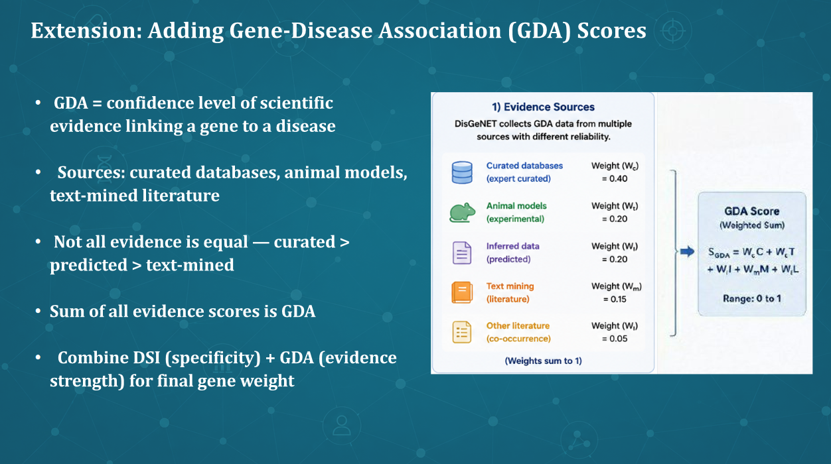

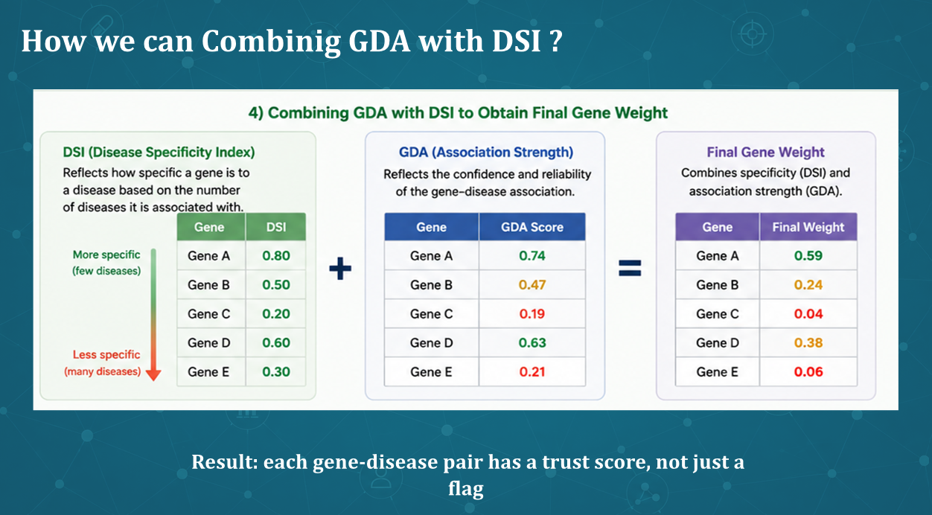
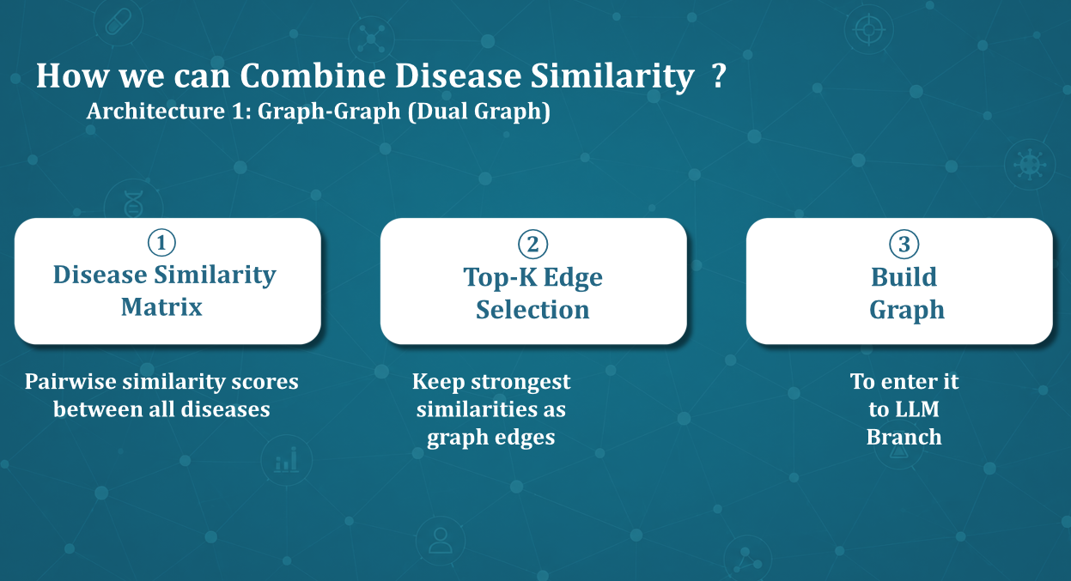
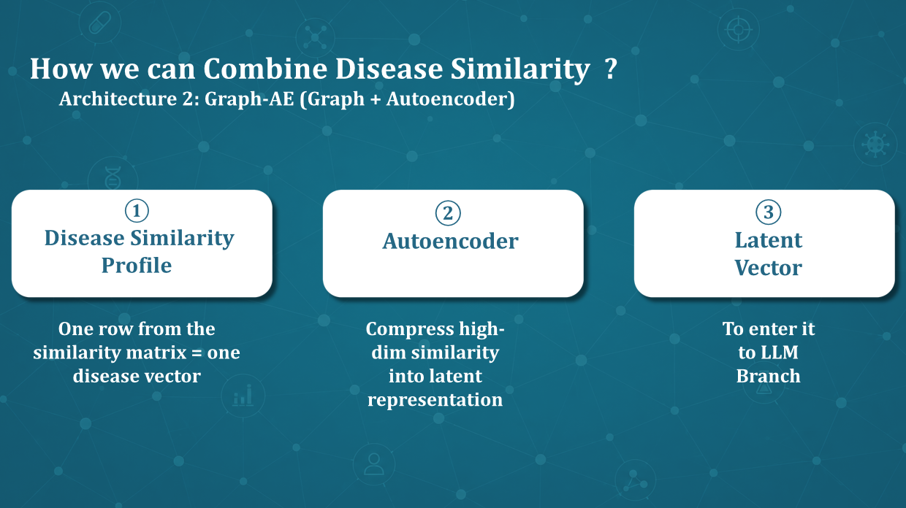’
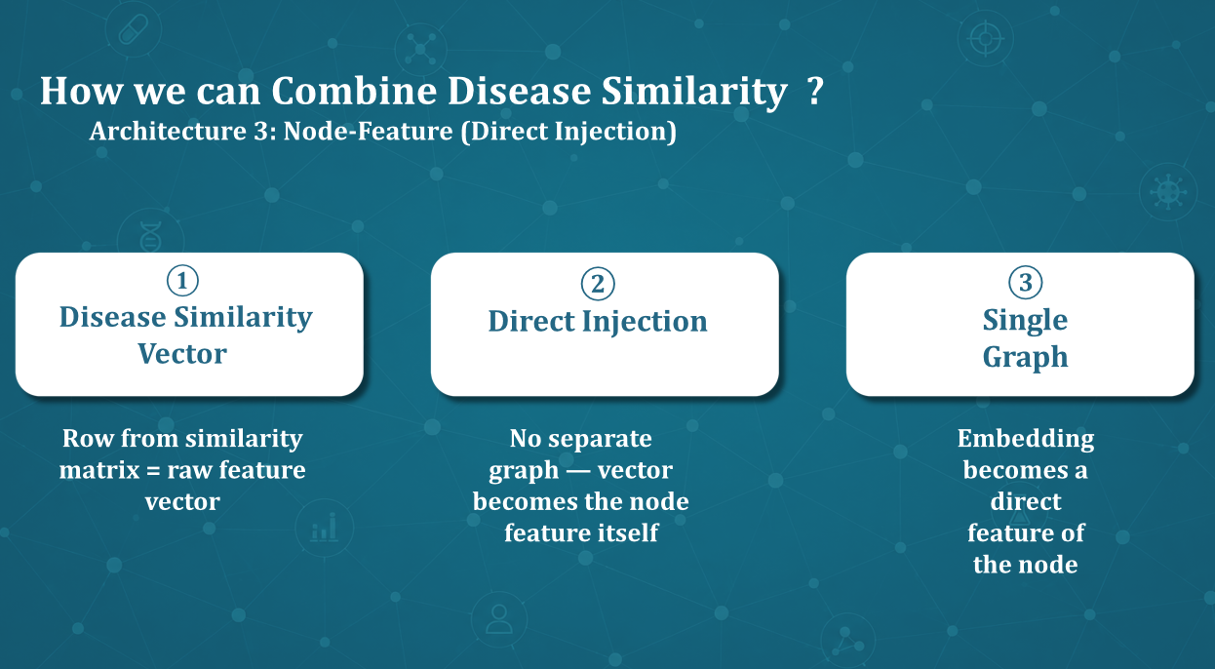
References
1. https://pmc.ncbi.nlm.nih.gov/articles/PMC5461528/ PMC
- https://www.sciencedirect.com/science/article/pii/S1532046411002073 ScienceDirect
- https://support.disgenet.com/support/solutions/articles/202000100283-what-are-the-gda-score-vda-score-disgenet-score-
- https://pmc.ncbi.nlm.nih.gov/articles/PMC1885563/
The Human Disease Network — Goh, Cusick, Valle, Childs, Vidal & Barabási (2007)https://doi.org/10.1073/pnas.0701361104

